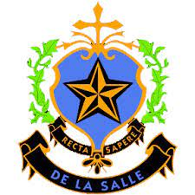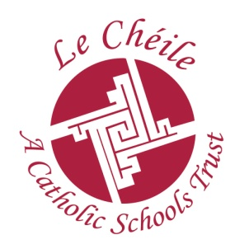

DEPUTY PRINCIPAL
De La Salle College Dundalk

The Board of Management of De La Salle College invites applications from suitably qualified persons for the post of Deputy Principal to take effect from 1st September 2021. The school is a Catholic Voluntary School under the trusteeship of Le Cheile Schools Trust. The school is an all boys school with an enrolment of 680.

Application forms may be obtained by email from applications@delasalle.ie
Or at www.delasalle.ie/appointments

Completed application forms should be submitted by email no later than
12 pm on 02/06/2021.

Short listing may apply

The school is an equal opportunities employer.

